Contents and Quantities for Mega Kits to Support Pfizer Vaccine

December 11, 2020

This is a clarification about the needle and syringes included in the COVID-19 ancillary supply kits for administering Pfizer’s ultra-frozen vaccine. Based on questions coming into our call centers supporting the distribution of the ancillary supply kits for Operation Warp Speed, there is some confusion about the quantities of needles and syringes included in the kits. Each kit is clearly labeled with a complete inventory list. (See example below.)
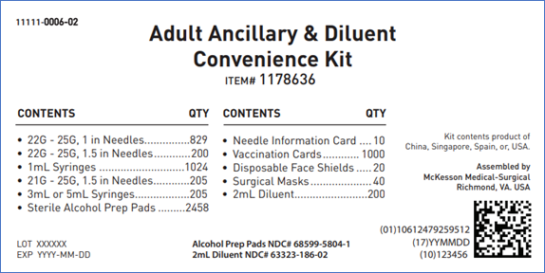
Procuring the sheer number of needles and syringes needed to support an operation of this size involves complex logistics, which is why vaccine administrators may see variance in how the supplies are packaged. The listed products may be received as a combo, defined as a single packaged needle and syringe, or as individual components. The quantities listed on the label represent the minimum number of total combinations in each kit.
- For example, if the kit above was shipped with (829) 1ml-25Gx1” syringe/needle combos and (200) 22Gx1.5” needles for administration, the kit would only contain (200) 1ml syringes to accompany the needles. This would yield a total of (1,029) needles with accompanying syringes (some packaged together, some individually).
- If a kit contained only individual needles and syringes, there may be 5 more needles than syringes. This is intentional and is designed to improve your experience and maximize the inventory across all kits built.
  - In this scenario, the adjustment was to the 22-25Gx1.5” needles. The kit was originally configured to have 195. This was increased by 5 (to 200) to improve the administrators’ experience by using two whole boxes.
Please note there will be multiple configurations used as Operation Warp Speed continues to procure products to support the assembly of these and other ancillary supply kits. Regardless of configuration, the kit contents will meet the minimum quantities listed on the kit content labels and will support the same total number of doses.
We hope this communication helps your teams as they review the content in the kits to ensure their readiness for administration when you receive the vaccine doses.
Please direct any issues regarding the ancillary kits to support the Pfizer COVID-19 vaccine to McKesson Customer Service at:
McKesson Customer Service
Phone #: 833-272-6634
Email: SNSSupport@McKesson.com

