Obtaining and Requesting PPE
PPE includes all equipment and supplies needed to protect a person from the spread of infectious disease. All providers are expected to have PPE available. Providers should first attempt to obtain PPE through their normal supply chain or through other resources typically available to them. These options may include:
- Contacting any sister facilities for coordination,
- Reaching out to local partners or stakeholders,
- Looking at any possible reallocations in coordination with your Hospital Preparedness Program (HPP) Provider.
The HPP Providers oversee the coalitions within Texas who assist healthcare facilities and providers with preparedness and response efforts. If your facility cannot obtain any PPE from their vendor(s) and have exhausted all alternative options, please contact your HPP Provider to discuss your request. Contact information and a map can be found at these links:

RAC contacts

Map of RACs
Map of Trauma Service Areas with RAC Names
An official request for resources should be made through the local office of emergency management and they will submit a State of Texas Assistance Request (STAR). Please note that this is not a guarantee of receiving PPE; supplies of PPE may be insufficient to meet demand.

Request Process Flow Chart

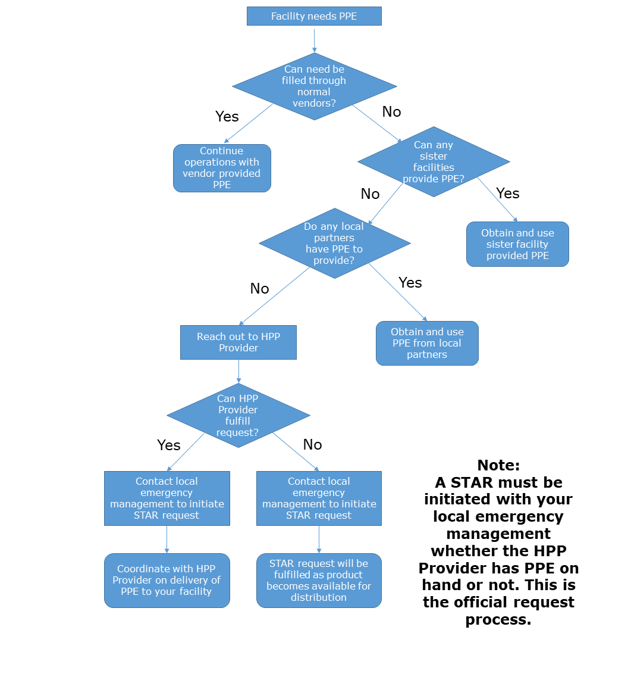

Optimizing PPE usage
Providers who are having difficulty obtaining PPE should follow national guidelines for optimizing their current supply of PPE or identify the next best option to care for individuals receiving services from the provider while protecting staff.
For the most current guidance on the use of PPE and how to conserve PPE, access resources from DSHS and CDC. The CDC COVID-19 website has sections for healthcare professionals and healthcare facilities. The CDC also has specific information relating to:
- Healthcare Supply of PPE
- Strategies to Optimize PPE and Equipment
- Strategies to Optimize Eye Protection
- Strategies to Optimize Isolation Gowns
- Strategies to Optimize Facemasks
- Strategies to Optimize N95 Respirators
- Crisis Alternate Strategies for N95 Respirators

